Regulations:
A14

H.T No

Sreenidhi Institute of Science and Technology
(An Autonomous Institution)
Code No: 4AC41 Date: 03-Jan-2019 (FN)

B.Tech I-Year II-Semester End External Examination, Dec-2018/Jan-2019 (Supplementary)
BASIC Electrical Engineering (BT)

Time: 3 Hours Max.Marks:70

Note: a) No additional answer sheets will be provided.
b) All sub-parts of a question must be answered at one place only, otherwise it will not be valued.
c) Missing data can be assumed suitably.

Part - A Max.Marks:20

Answer all QUESTIONS.

1. | State Kirchhoff’s Laws. | [2M]
2. | Explain the terms Average value and Peak Factor. | [2M]
3. | Derive the condition for maximum efficiency in a D.C Generator. | [2M]
4. | What are the different losses present in a transformer? | [2M]
5. | Obtain the relation between phase voltages and line voltages in a star connected system. | [2M]
6. | Explain the classification of measuring instruments. | [2M]
7. | State Superposition theorem. | [2M]
8. | A 2kVA, 115/230V, single phase transformer has an iron loss of 40W and full load copper loss of 100W. What is the load kVA at maximum efficiency. | [2M]
9. | A three phase induction motor is wound for 6 poles and is supplied from 50Hz supply. Calculate (i) Synchronous speed, (ii) slip when the motor is running at a speed of 900rpm | [2M]
10. | A series circuit having a resistance of 5Ω and an inductive reactance of 4Ω is supplied from a 230V, 50Hz supply. What is the current flowing in the circuit and the power consumed by it. | [2M]
Part – B Max.Marks:50
ANSWER ANY FIVE QUESTIONS. EACH QUESTION CARRIES 10 MARKS.

11. | a) | Explain the principle of source transformation in electrical circuits. | [4M]
 | b) | 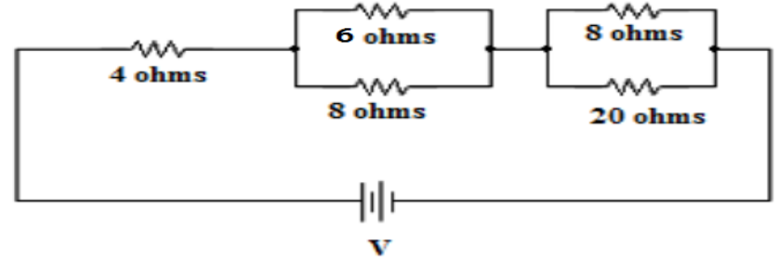  The current in 6Ω resistor of the network shown in Figure.1 is 2A. Determine the currents in all resistors and the voltage across the network.  Figure.1 | [6M]
12. | a) | Define the following terms:  (i) Instantaneous value (ii) Cycle (iii) Time period (iv) Frequency | [4M]
 | b) | An inductive coil having a resistance of 15Ω takes a current of 4A when connected to a 100V, 60Hz supply. If the coil is connected to a 100V, 50Hz supply,  Determine (i) Current, (ii) Power consumed by the coil, (iii) Power factor. | [6M]
13. | a) | Explain the principle of operation of a D.C Generator. | [4M]
 | b) | A 4-pole, lap connected 230V shunt motor has 410 armature conductors. It takes 41A on full load and the flux per pole is 0.05Wb. The armature and field resistances are 0.1Ω and 230Ω respectively. Brush contact drop is 1V per brush. Determine (i) Speed of the motor, (ii) Total torque developed in the motor. | [6M]
14. | a) | Derive the EMF equation of a single phase transformer. | [5M]
 | b) | A single phase transformer is connected to a 230V, 50Hz supply. The net cross sectional area of the core is 60cm². The no. of turns in primary is 500 and in the secondary 100. Determine (i) Transformation ratio, (ii) Induced EMF in the secondary winding, (iii) Maximum flux density in the core. | [5M]
15. | a) | Explain the principle of operation of a three phase induction motor. | [5M]
 | b) | Derive the torque equation of a three phase induction motor. | [5M]
16. | a) | Discuss about the construction and principle of operation of Permanent magnet Moving Coil(PMMC) instruments with neat sketch. | [6M]
 | b) | Write the advantages and disadvantages of PMMC instruments. | [4M]
17. |  | Find the equivalent resistance across the terminals AB shown in Figure.2 by using star – delta transformations.  Figure.2  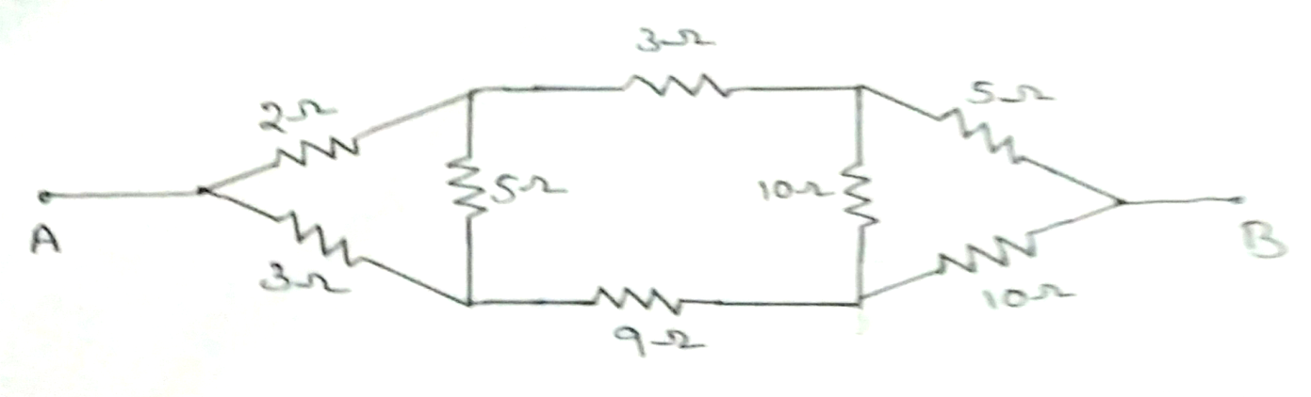 | [10M]
18. | a) | The load in each branch of a star connected three phase circuit consists of 15Ω in series with 0.05H inductance. The supply line voltage is 430V, 50Hz. Calculate the phase voltages and phase currents of the load. | [5M]
 | b) | Explain the significance of controlling torque and damping torque relevant to the operation of indicating instruments. | [5M]

-- 00 -- 00 –

